Lab Goal: The goal of this lab is to show you how to clean up your main method. You must create a single jeroo method, and your main method can only have “Jeroo bob = new Jeroo();” and “bob.go();” written once. This lab teaches you how to loop jeroo methods and keep the code clean.

Lab Description: For this lab, the main method has to be as minimalist as possible. To do this, you will create a single jeroo method to clear the whole Jeroo island of flowers and nets. The main method can only contain “Jeroo bob = new Jeroo();” and “bob.go();” written once.

**Starting Screen:**

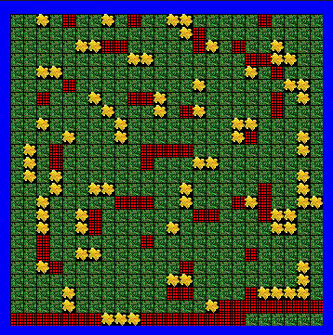

**Ending Screen:**

